Directions to Animals in War Memorial

Leave Marble Arch tube station by the Park Lane exit

Approximately 300 yards on left is Upper Brook Street –
the Memorial is opposite

Reception

Please join us after the service for refreshments
Upstairs at the Portman Marylebone
51 Upper Berkeley Street, London W1H 7QW

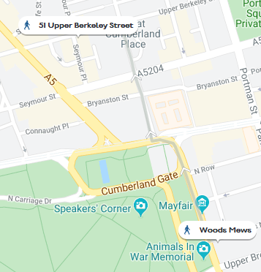

The reception venue is approximately 10 minutes’ walk from the Memorial.

From the Memorial :

Walk back up to Marble Arch – Oxford St will be on your right
Cross over and walk along Great Cumberland Place for 250m,
crossing over Bryanston Street and Seymour Street
Turn left onto Upper Berkeley Street

Venue is approximately 100m on the left,
on the corner of Upper Berkeley Street and Seymour Place

NB: only assistance dogs allowed in this venue

